**MIS based on MySQL as database for priority**

Liu Yitao Computer Science Technology International School. Jinan University

**Abstract**

MIS is Management Information System. To build a MIS, we need to store the information of users and determine their identity. We need a UI to register and sign in.

**Introduction**

This program require a database to store the information of users. I choose Mysql as my database. Because mysql is very efficient and big-capacity compared with Access. And I use Mysql Workbench to organize my mysql tables. I create 7 columns in the table named id, name, password, phonenumber, mail, sex, VIP. Id is the unique number of every user. Name and Password are set by user and to confirm the users. VIP is the number of user’s identity. 0 for student, 1 for teacher, 2 for administrator. It help to determine the priority of users.

I use JAVA to create a UI of registering and signing in. After installing the driver of jdbc for java. It can connect to my database and use SQL language to search, change, delete, add data to mysql.

**Requirement**

1. We need a register/sign in frame to admit user to input their information. This is developed by Java swing.
2. We need a database to store the information of users. I use mysql to store information in a table named student. I can use jdbc to connect mysql by java.
3. We need to determine the priority of users( by determine the VIP value ). And for students, we allow them to play game between 6:00 to 22:00; for teachers, we allow them to play game between 8:00 to 17:00; for administrator, we allow them to play game any time. These information would be showed in another frame.
4. Before registering and signing in, we need an identifying code to confirm the user is not a “robot”.

**Main Class**

There are three main class in this program called Forsql.java, infoframe.java, and signframe.java.

In Forsql.java, I create some methods to connect to mysql to search, add, delete and change data in the database. It’s very convenient for other classes to use these methods.

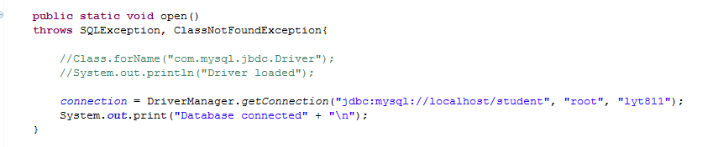

This is the code to connect the database.

In signframe.java, I create a frame for registering and signing in.

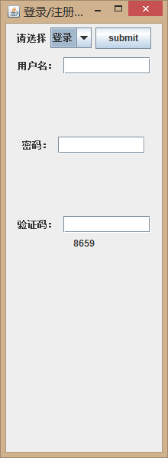 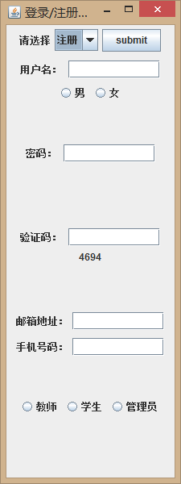

After users inputing all the information. It will check if the identifying code is correct. And then it will check if the id can be found in the database. Finally it check if the password is correct.

After identifying these information, it comes to the infoframe.java. This class shows if the user can play games. Or furthermore, search/change/delete/add the data in the database.

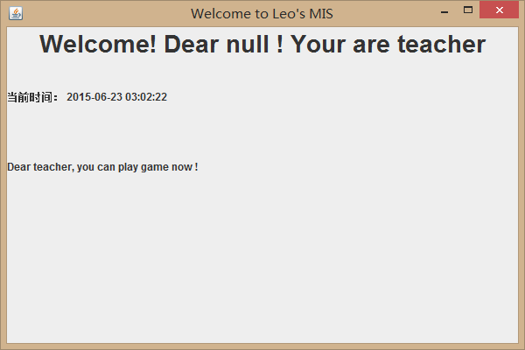

**Core Algorithm**

Yanzhengma.java

Signframe.java

Forsql.java

Rigister

Sign in

Signin(arglist)

Insert(arglist)

Infoframe.java

Determine the priority

Open()

Mysql student table

**Conclusion**

This paper shows how to use mysql to store the information of users. And use java to connect mysql to organize the data in database. Finally we get a management information system.

**Environment:**

IDE: Eclipse Luna

System: Windows 8

Database: mysql 5.1.73, Mysql Workbench

Java jdk&jre: 1.8